**Excel Assignment – 10**

**1. See the below picture and create the exact table with exact formatting.**

**Font – ‘Times New Roman’ Size – 14, Color of first line Orange.**

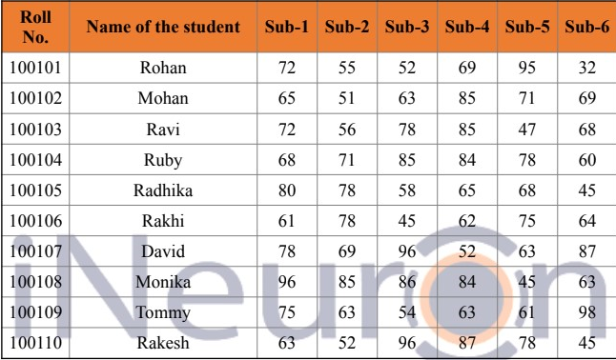

* 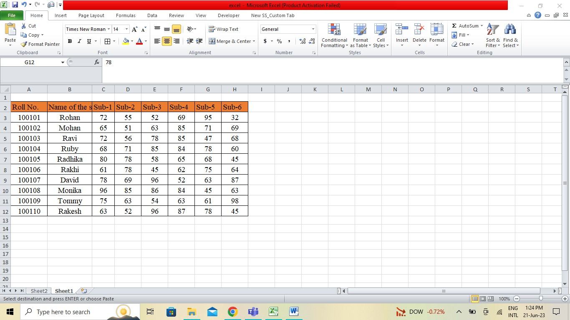

**2. From the above table use Sum Formula and find the total for each**

**student.**

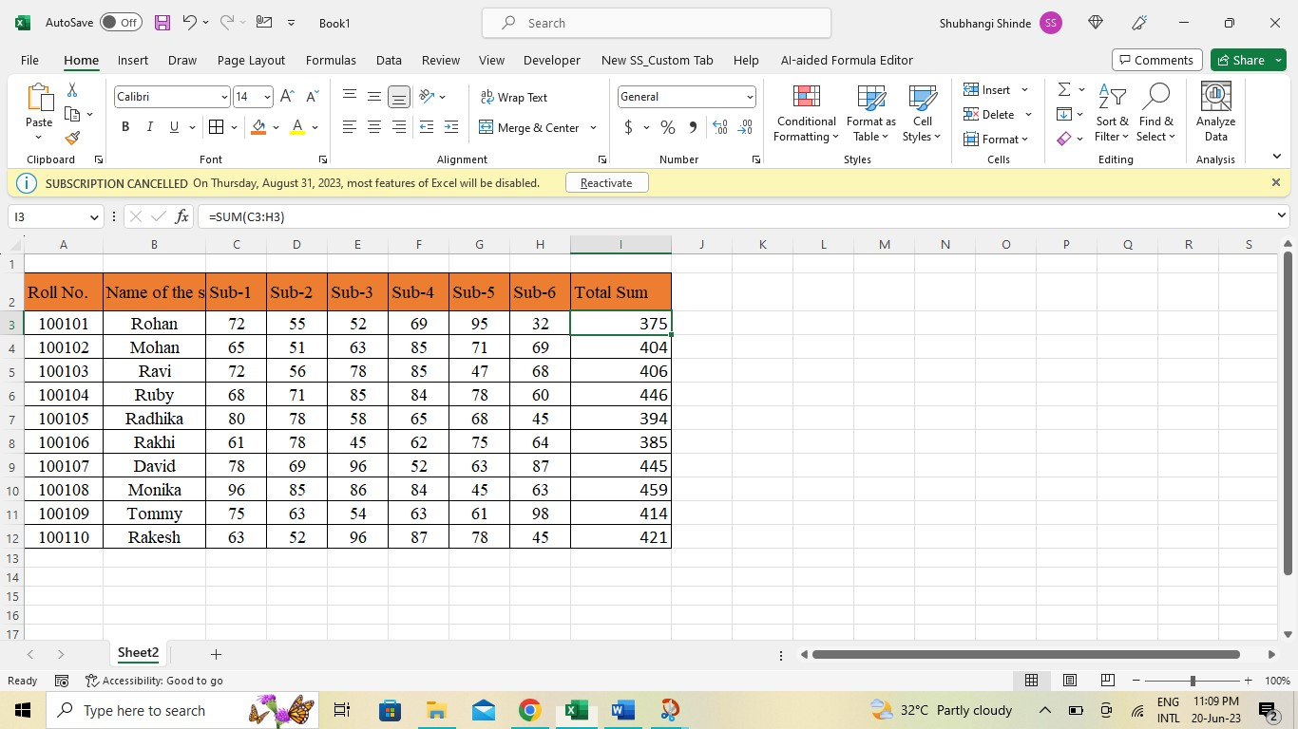

* The table start from the cell A3,select an empty cell where you want the total to be displayed.
* In cell I3, enter the SUM formula. The formula should include the range of cells for the scores of the student.
* Press Enter to calculate the total for the first student.
* Copy the formula and paste it down to the remaing cells in column I .

**3. Calculate Average for each student in the next row. Use Formulas.**

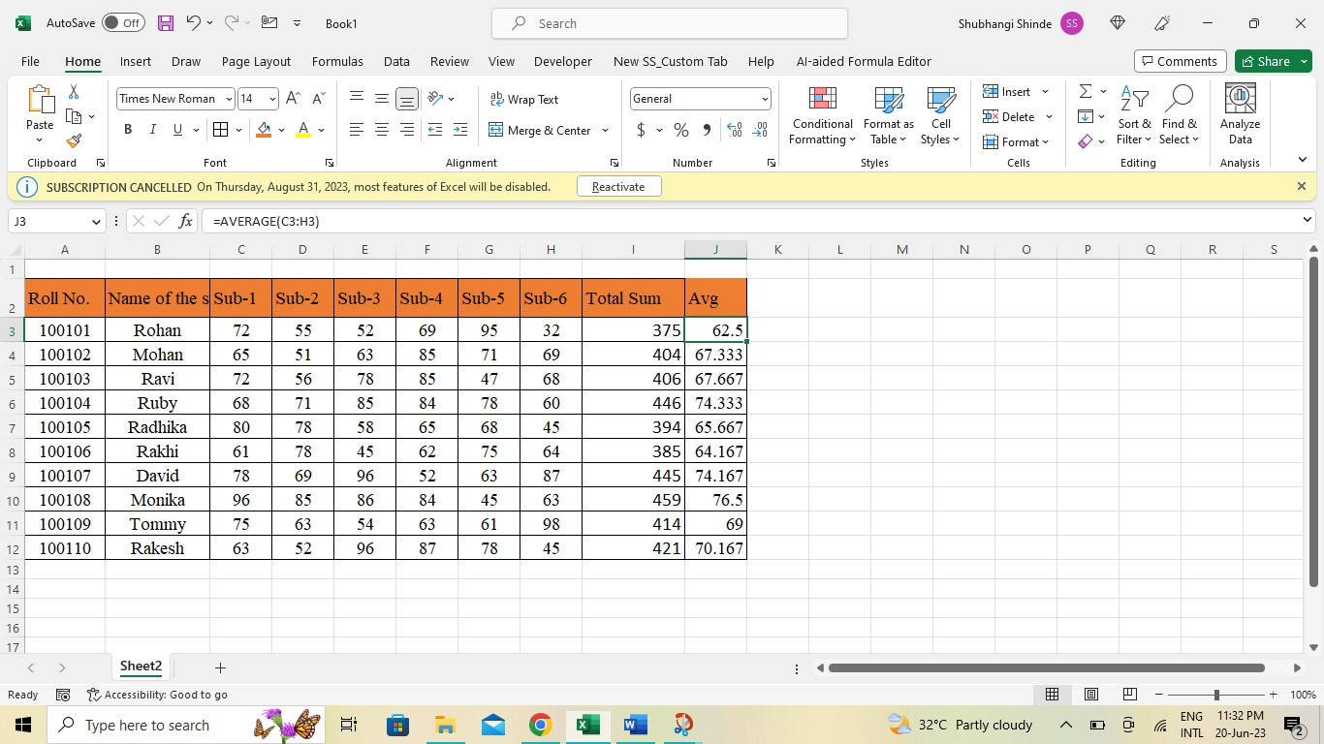

* The table starts from cell A3,Select an empty cell where you want the average to be displayed.
* In cell J2 ,enter the AVERAGE formula. The formula should include the range of cells for the scores of the student. Formula = =AVERAGE(C3:H3) .
* Press Enter to calculate the average for the first student.

**4. Calculate Rank for each student. Use Formulas.**

- To calculate the rank for each student, you need to have some criteria or scores based on which the ranking will be determined. Without scores, it is not possible to calculate the rank .

- Use RANK.EQ formula assigns unique ranks to the scores, with the highest score receiving the rank of 1. In an empty column, enter the following formula for each student =RANK.EQ(I3,$I$3:$I$12,0)

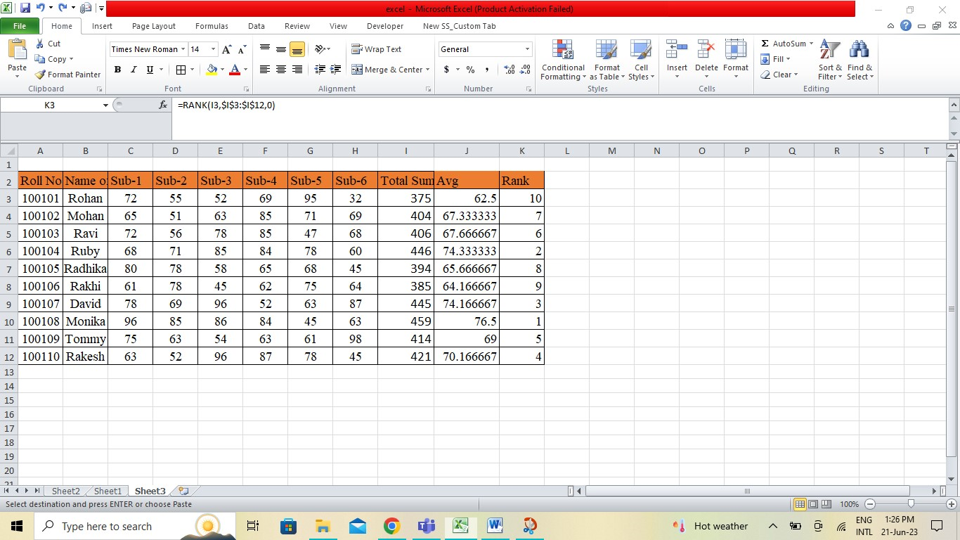

**5. Calculate Percentage for each student. Use Formulas. Round off the**

**decimals up to 2 points.**

- To calculate the percentage for each student in Excel and round off the decimals upto two points, you can follow these steps:

a. Gather the scores for each student.

b. Use the formula to calculate the percentage.In an empty column,enter the following formula for each student, replacing I3 with the cell reference containing the student score

=ROUND(I3*100/600,2).

